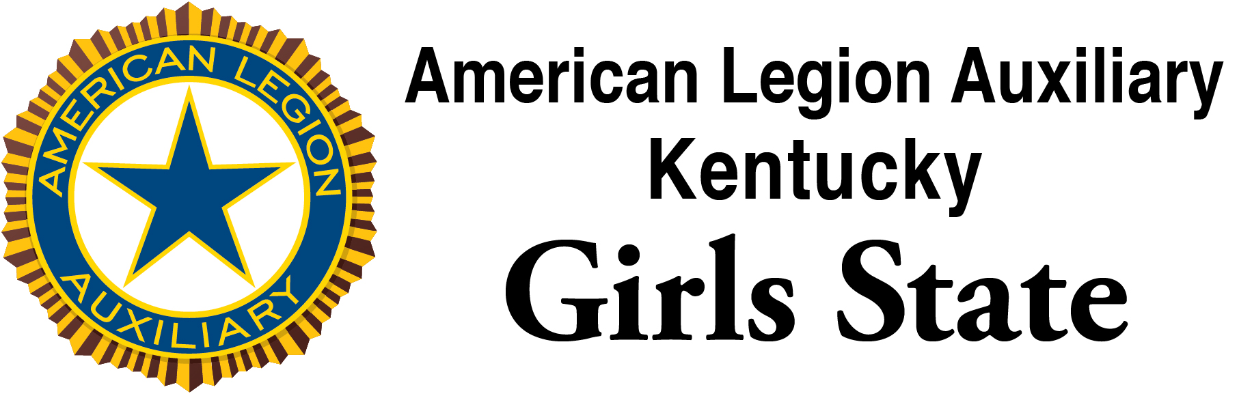
Congratulations on your selection to attend the 77th session of American Legion Auxiliary Kentucky Girls State (ALA KGS). Our staff is excited about this year’s session and is looking forward to meeting you.

ALA Kentucky Girls State will be held on the campus of Western Kentucky University, Bowling Green, KY from Monday, June 3 through Friday, June7, 2024. Registration will begin on Monday, June 3, 2024, at 11:00 AM CDT and will continue until 1:00 PM, CDT. Registration will be in the lobby or front porch of the residence hall, depending on the weather. The precise location will be shared before arrival. If you arrive before 11AM, your room may not be ready. Therefore, please try to arrive during the time specified.

As part of your registration, you will need to submit your Medical Certificate upon arrival. The Medical Certificate is included in this mailing.

There will be several offices that you can run in your city and there are a number of offices at the state level for which you can run. Positions are also available in the legislature. A list of the offices is attached. You can also go to www.kentucky.gov to view general information on state offices and connect to links from there. Materials will be available in your city to make campaign posters, etc. Professional, preprinted campaign material is not permitted. Your originality and imagination are great assets in preparing campaign materials.

A sample bill is included in this mailing as well as a blank bill form. Please consider preparing a bill, before arriving, on a topic of state concern to you.

Here is a Packing List of items to bring:
Casual, comfortable clothing that you would normally wear to school –
Please do not wear –tops with bare shoulders, spaghetti straps, or bare midriffs.
-extremely short shorts (primarily athletic shorts) outside the dormitory.
Two or three professional outfits, if you run for State Office
An appropriate outfit for the field trip to the State Capitol in Frankfort
Workout clothes (if you want to exercise)
Hangers (there are none in the closets)
An umbrella or poncho in case of rain
Comfortable shoes
Bed linens – pillow, sheets (2 twin size flat), pillowcase, blanket and towel and washcloth
Toiletries, including soap, shampoo, toothbrush and toothpaste, and makeup.
A light jacket
A mirror
Hair dryer, curling iron, hot rollers, etc.
Sanitary products
Camera and film
An alarm clock, if you don’t want to use your phone.
Spending money for city picture, snacks and pizza, or laundry

There will be a talent show Thursday night. If you want to take part in the talent show, you should bring what you will need for your act, if possible. There will be a piano available, as well as a CD player for music you may bring. We strongly urge you to participate in the talent show as it is one of the highlights of the week.

In addition to your personal needs, we ask you to participate in a service project being conducted this year to aid homeless veterans. Each ALA KGS participant is requested to bring a pair of new socks. American Legion Auxiliary members will distribute these socks to homeless veterans in multiple locations across the state.

By participating in the ALA Girls State Program, you may be eligible to apply for up to $10,000 in scholarship offered by the American Legion via a grant from the Samsung Corporation. Eligibility requirements for the Samsung American Legion Scholarship involve being a direct descendent of an American wartime veteran. The specific dates for military service and the eligible descendants are available via the American Legion Website at
www.legion.org. One scholarship is awarded in each Girls State Program, with the minimum winner receiving a projected $1,250. Type Samsung Scholarship in the search box to locate the information and portal to prepare and submit the application. All applications must be completed online, and applications must be completed by 11:59PM Monday, June 3. After that time, the portal will not allow any additional input into the system by the applicants.

If you drive to ALA Kentucky Girls State, you will be required to surrender your car keys upon your arrival. You will also be required to complete a form giving specific information on your vehicle. Your keys will be returned on Friday morning, June 7, 2024. Our last session should be over by 10: a.m. on Friday.

If for some reason after you are chosen, you cannot attend Girls State, please contact the American Legion Auxiliary Unit Chairman or the person in your area who has been working with you, as soon as possible. You may also contact the Director listed below. Your fee to attend the program has been paid. If we are given sufficient time, we can get someone else to attend in your place. This is very important, because the American Legion Auxiliary members have worked hard to raise this money and that money is forfeited if you do not attend. Please, do not back out at the last minute. If you have any doubts about attending, please give us enough time to replace you.

Upon your return home, we encourage you to write a letter of thanks to the American Legion Auxiliary Unit or American Legion Post that sponsored you for this program. You will be given a card with the name and address of the individual to contact.

We hope that you have a fantastic time at ALA Kentucky Girls State, and we look forward to working with you!

Virginia Hobbs, Chairman  297 Terrace Drive  Radcliff, KY 40160  (270) 300-6060 (c)  Email: director_alakygs@outlook.com | Diane Spencer, Director  1849 B Chatsworth Drive  Lexington, KY 40505  (859) 285-8616 ©  Email: diane.spencer@uky.edu

