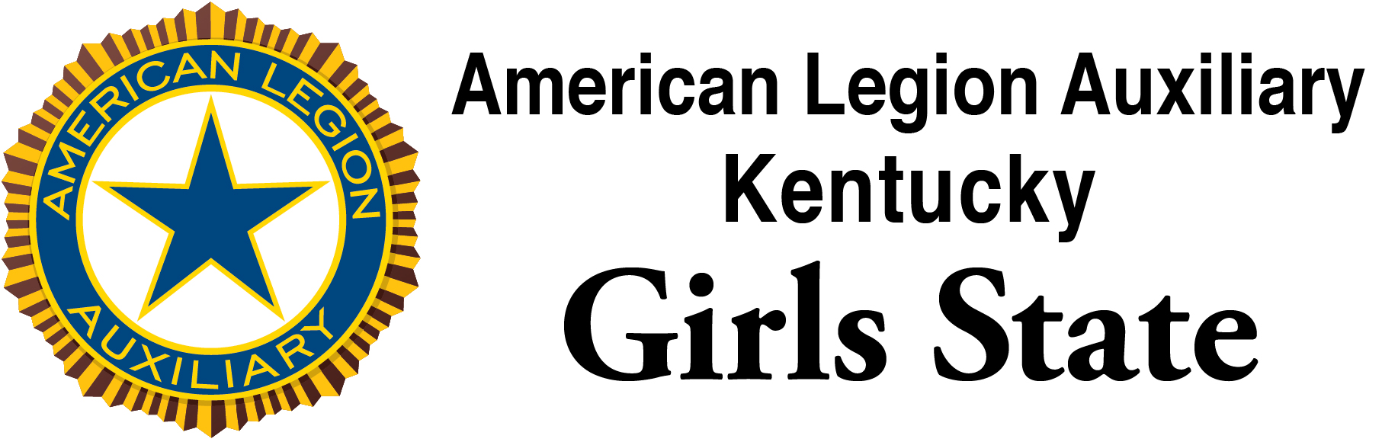

American Legion Samsung Scholarship

By participating in the ALA Girls State Program, you may be eligible to apply for a $10,000 scholarship offered by the American Legion via a grant from the Samsung Corporation. Eligibility requirements for the Samsung American Legion Scholarship involve being a direct descendent of an American wartime veteran.

Each ALA Girls State session will have one winner for a minimum of $1,250. Higher scholarship amounts are available for national winners. Information on the numbers and amounts for scholarships are available via the link below.

Information on applying for the scholarship is available from the American Legion Website at:
https://www.legion.org/scholarships/samsung.

All applications must be completed online, and applications must be completed by Midnight Monday, June 3. After that time, the portal will not allow any additional input into the system by the applicants.

The winner from ALA Kentucky Girls State will be announced at the closing ceremony on Friday, June 7.

